MEMBER CONTRIBUTION PLEDGE 2026

THE EUROPEAN ROMA INSTITUTE FOR ARTS AND CULTURE

I, _________________________________________________________________, proudly affirm my commitment as an associate member of the European Roma Institute for Arts and Culture. I believe in the power of our collective efforts and want to play my part in turning our shared vision into reality. This is why I will contribute to the growth and success of our community in 2026.

As part of this commitment, I pledge to provide the following in-kind contribution to ERIAC:
[Please describe your in-kind contribution]

Estimated Monetary Value: _______________________________
[Please indicate the approximate monetary value of your contribution]
By submitting this pledge, I confirm my dedication to ERIAC and its future development. I acknowledge that this pledge constitutes my in-kind contribution for the year 2026, in accordance with the ERIAC Membership Charter.

Name (Individual or Organisation): _______________________________________________

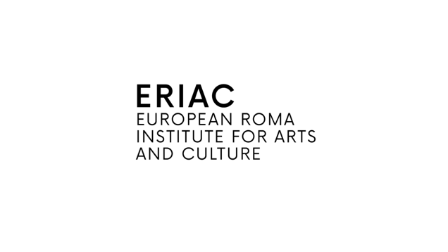
Date: ___________________________ Signature: _____________________________

